Jacqueline Nguyen

3033124694

September 9, 2017

ME 290U HW2 Text Entry

**Guitar Text**

Inspired by the musical meaning of “chording” I chose to make a text entry device based on creating “chords” on a guitar to “play” letters. I organized Guitar Text to have 3 pairs of tactical switches to act as frets and 1 additional switch to imitate the act of strumming a guitar. This layout allows for 27 combinations of key presses to map to the alphabet and a space key (Figure 1). The user can hold down different combinations of 6 switches on the frets to choose a letter.

Fret Buttons

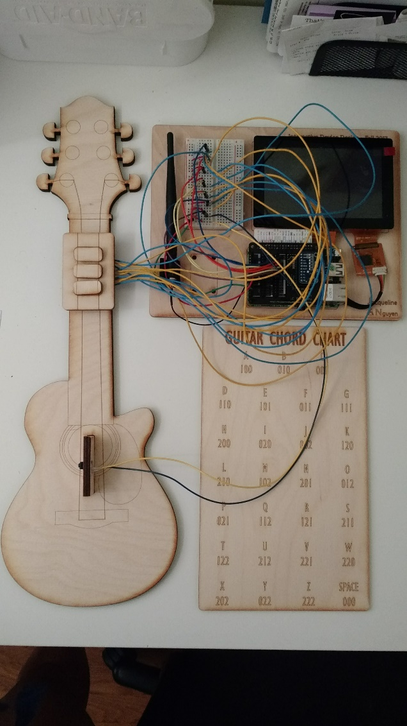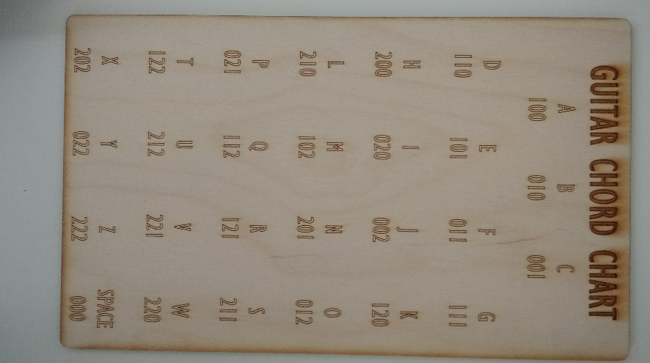

Strum Button

Figure 1: Guitar Text system and Chord/Letter Key

**Wiring and Programming**

Guitar Text requires 7 switches, each connected to a different GPIO pin on the Pico Pro. The switches are mounted on the guitar such that the user can hold down 0, 1, or 2 switches on each fret. To operate Guitar Text, the user presses and holds down the desired fret combination, then presses the strum button. Release of the strum button signals the Guitar Text app to look at each GPIO pin to determine which buttons were held down and translates the combination to the corresponding letter. Figure 2 explains how to interpret the chord chart. Figure 3 shows the wiring diagram of the 7 pull-up resistor circuits.

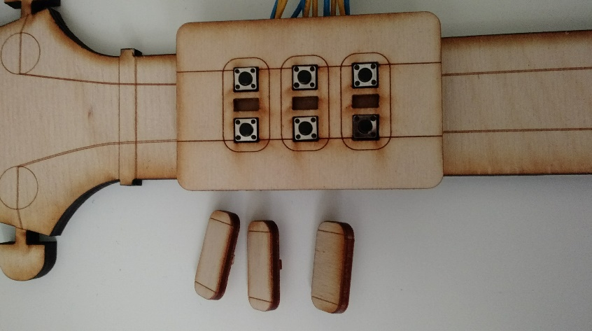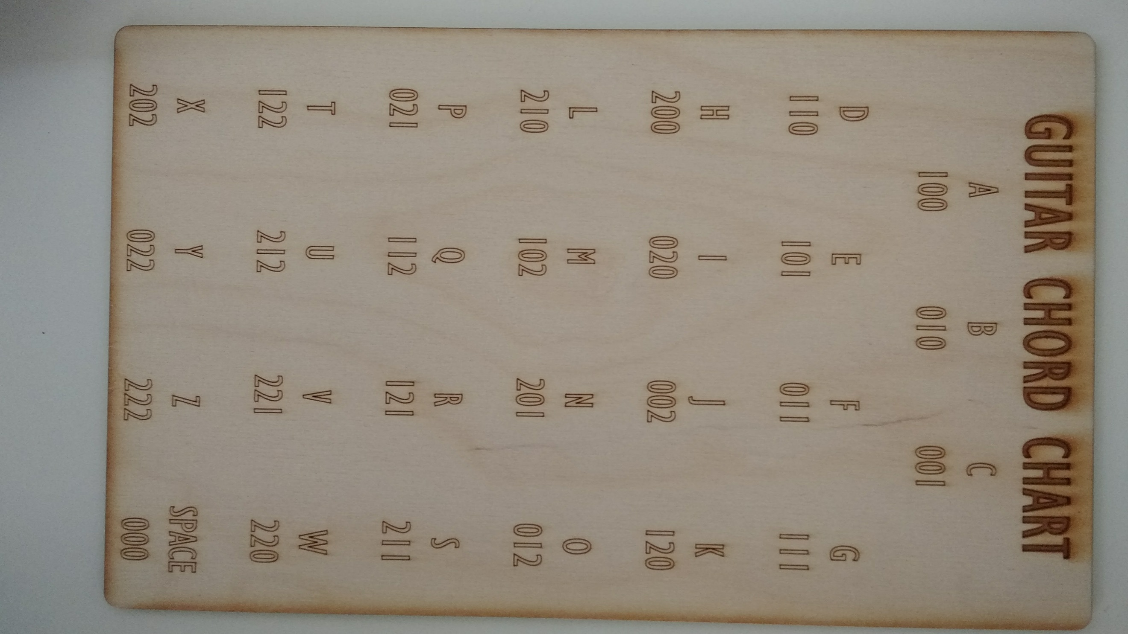

Figure 2: Guitar Text frets assembly and corresponding number on the chord chart.

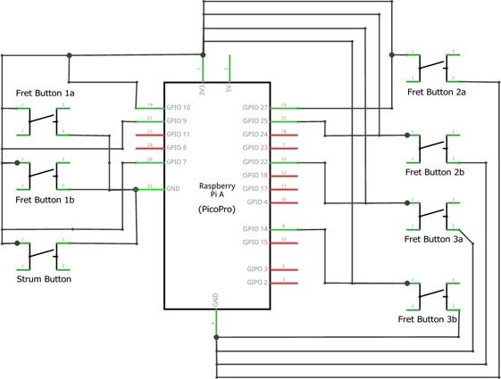

Figure 3: Guitar Text wiring diagram (Created with Fritzing)

**­­­­­­Physical Device**

The Guitar Text requires the user to be able to press various key combinations with one hand. Thus, I designed a small wood guitar using Illustrator and a laser cutter. The tactical switches are mounted in a 2 x 3 array so the user can operate the switches using three fingers on one hand. The strum switch is mounted on the guitar body. (Figure 4).

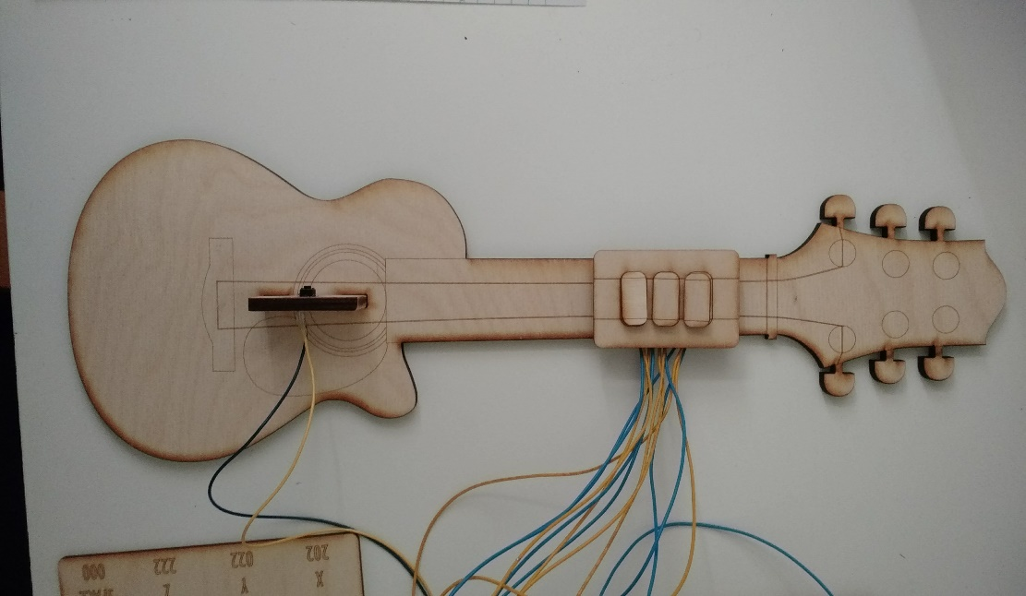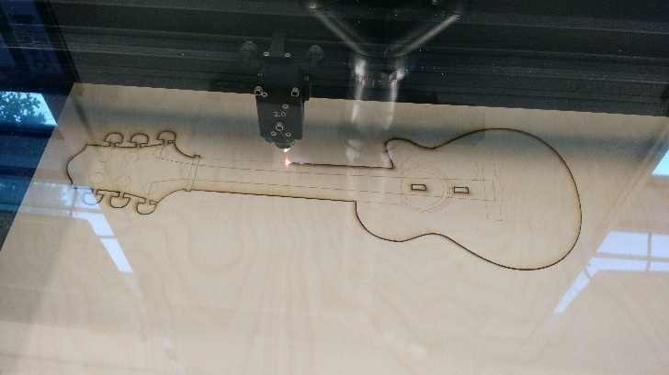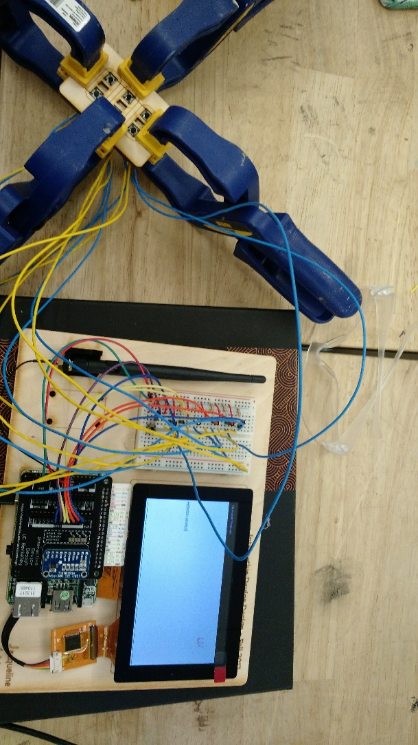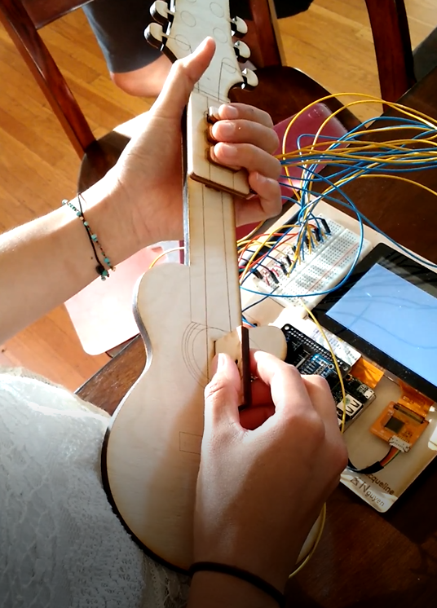

Figure 4: From top left, clockwise. User playing keys on the Guitar Text device, laser cutting guitar body, gluing fret buttons onto fret mount, fully assembled guitar with strum and fret buttons.

**Reflection**

Overall, this assignment was not technically difficult. However, I needed a week to begin to begin working I was not clear on where to start, gather materials, and clarify the processing functions integrated in the Simple Pico Pro script. After clarifying many of these issues, the project felt appropriately difficult. I really enjoyed learning new breadboarding skills and familiarizing myself with Jacob’s Hall.